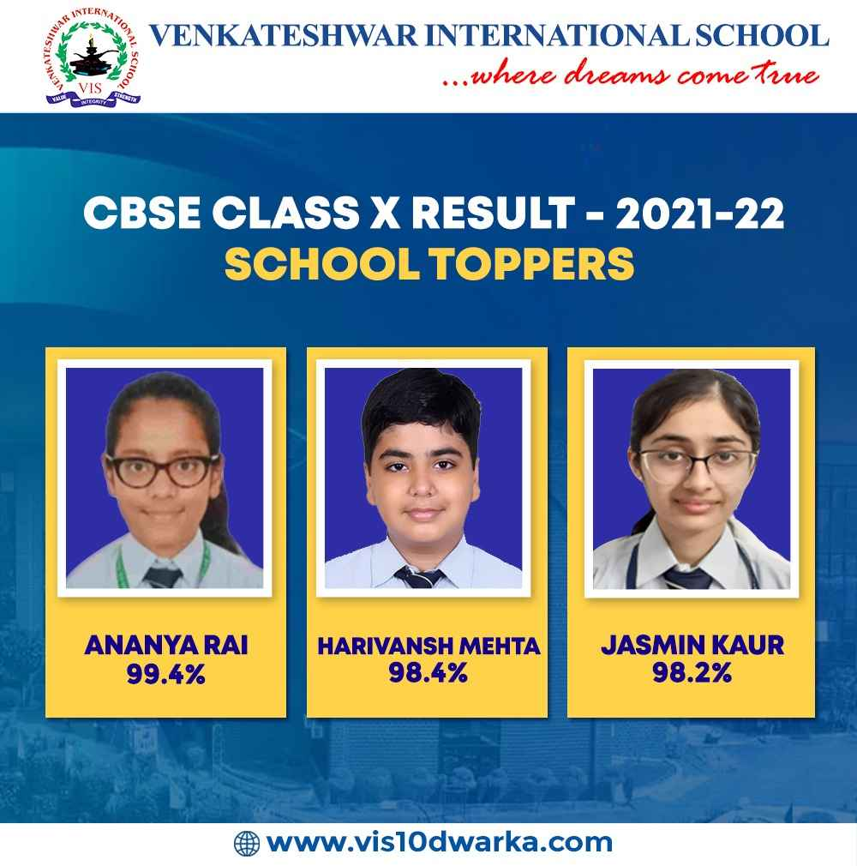
CBSE CLASS X RESULT 2022-23
SCHOOL TOPPERS

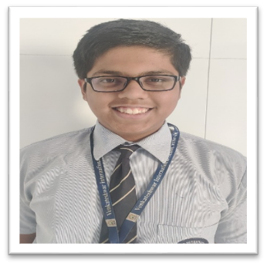


SHANTANU GHOSH
97.6 %



ANV
AGRIM GARG
96.8%
ANISH KUMAR RAM
96.8%
VINAYAK MAJUMDER
97 %
TULIKA GUPTA
97 %

